EXPERIMENT 2 – Logical and Bit-Manipulation Operations Using 8085
1. Aim
To develop and execute 8085 assembly language programs for logical operations, bit masking, bit setting and clearing, one's and two's complement, rotate operations, logical and arithmetic shifts, and 8-bit and 16-bit data manipulation.
2. Objectives
- To perform AND, OR, XOR, NOT and NEG operations on 8-bit and 16-bit data.
- To apply masks to select, set, clear, toggle and test individual bits.
- To perform rotate and shift operations and analyze the carry flag.
- To count the number of set bits in an 8-bit value.
- To verify the outputs using manual bitwise calculations.
3. Expected outcomes
- Develop programs for logical operations and complements.
- Select appropriate masks for bit manipulation.
- Distinguish rotate, logical shift and arithmetic shift operations.
- Interpret carry and other relevant flags.
- Verify the results against theoretical values.
4. Software and hardware required
- 8085 simulator
- 8-bit microprocessor trainer kit
- Keyboard
- Power cord
5. Theory
Logical instructions operate on individual bits.
- AND (ANA, ANI): The result bit is 1 only when both input bits are 1.
- OR (ORA, ORI): The result bit is 1 when either input bit is 1.
- XOR (XRA, XRI): The result bit is 1 when the input bits differ.
- NOT (CMA): Inverts all bits of the accumulator.
- Two's complement: Obtained by inverting all bits and adding 1.
- Bit masking: Uses AND, OR or XOR to clear, set or toggle selected bits.
- Rotate: Moves a bit around the byte or through the carry flag.
- Logical shift: Shifts bits and inserts zero into the vacant position.
- Arithmetic right shift: Preserves the sign bit while shifting right.
6. Procedure
- Open the 8085 simulator or power on the trainer kit.
- Enter the program at the specified starting address.
- Load the input bytes and words into the input memory locations.
- Execute the program using GO/EXEC.
- Inspect the output memory locations and flags.
- Verify the results using the calculations below.

PROGRAM A – Bit masking and logical operations
Algorithm
- Initialize the stack pointer and load X and Y from memory.
- Perform AND and store the result and flag byte.
- Perform OR and XOR and store both results.
- Apply 0Fh and F0h masks to obtain the lower and upper nibbles.
- Use CMA to obtain the one's complement of X.
- Increment the complemented value to obtain the two's complement.
- Load the 16-bit word W, complement both bytes and store the one's complement.
- Increment the 16-bit value to obtain the two's complement.
- Halt.
Input memory map
Memory address | Input value | Description
4500h | A7h | Operand X
4501h | 3Ch | Operand Y
450Ah | 34h | W lower byte
450Bh | 12h | W upper byte
Thus, W=1234_h.
Output memory map
Memory address | Expected value | Description
4502h | 24h | X AND Y
4503h | BFh | X OR Y
4504h | 9Bh | X XOR Y
4505h | 07h | Lower nibble
4506h | A0h | Upper nibble
4507h | 58h | One's complement of X
4508h | 59h | Two's complement of X
4509h | 14h | Flags after AND
450Ch–450Dh | EDCBh | One's complement of W
450Eh–450Fh | EDCCh | Two's complement of W
Theory and calculations
AND, OR and XOR:
X = A7h = 1010 0111
Y = 3Ch = 0011 1100

AND 0010 0100 = 24h
OR 1011 1111 = BFh
XOR 1001 1011 = 9Bh
Nibble masking:
A7_h AND 0F_h=07_h
A7_hAND F0_h=A0_h
8-bit complements:
One's complement of A7_h=58_h
Two's complement =58_h+1=59_h
16-bit complements:
One's complement of 1234_h=EDCB_h
Two's complement=EDCB_h+1=EDCC_h
Expected output
The output memory locations should contain the values listed in the output map, with the AND flag byte recorded as 14h according to the lab document.

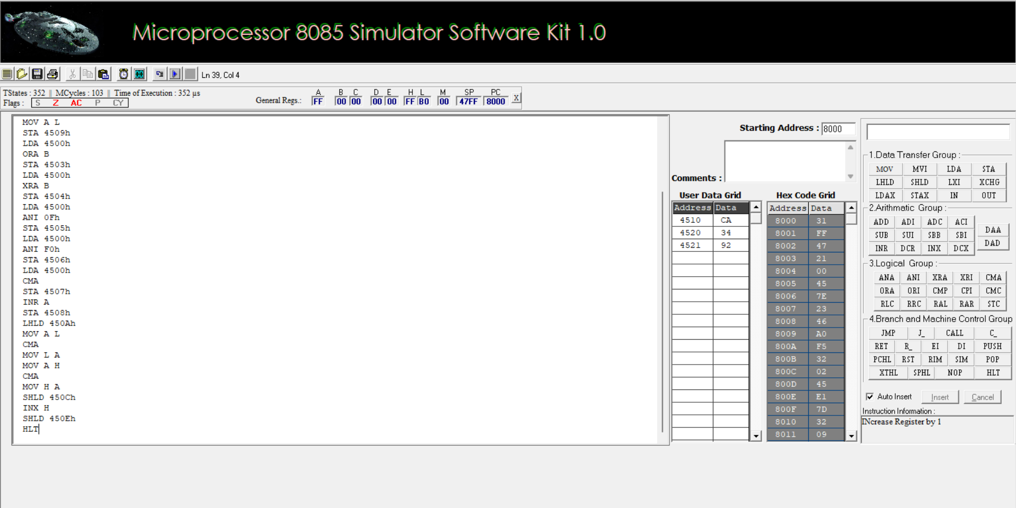

PROGRAM B – Bit setting, clearing, shift and rotate
Algorithm
- Load data byte D from memory.
- Set bits 7 and 0 using OR with 81h.
- Clear bits 3 and 1 using AND with F5h.
- Toggle the lower nibble using XOR with 0Fh.
- Test bit 6 and store 01h if set, otherwise 00h.
- Perform rotate-left and rotate-right operations.
- Perform logical left and right shifts.
- Perform arithmetic right shift while preserving the sign bit.
- Count the number of set bits by rotating the byte eight times and counting carry occurrences.
- Shift the 16-bit word left once using DAD H.
- Halt.
Input memory map
Memory address | Input value | Description
4510h | CAh | Data byte D
4520h | 34h | 16-bit word lower byte
4521h | 92h | 16-bit word upper byte
Thus, D=CA_h and the 16-bit word is 9234_h.
Output memory map
Memory address | Expected value | Description
4511h | CBh | Set bits 7 and 0
4512h | C0h | Clear bits 3 and 1
4513h | C5h | Toggle lower nibble
4514h | 01h | Bit-6 status
4515h | 95h | Rotate left
4516h | 65h | Rotate right
4517h | 94h | Logical shift left
4518h | 65h | Logical shift right
4519h | E5h | Arithmetic shift right
451Ah | 04h | Number of set bits
4522h–4523h | 2468h | 16-bit shift-left result
Theory and calculations
Input byte:
CA_h=11001010_2
Setting bits:
CA_h OR 81_h = CB_h
Clearing bits:
CA_h AND F5_h = C0_h
Toggling the lower nibble:
CA_h XOR 0F_h=C5_h
Testing bit 6:
CA_h text AND 40_h = 40_h
Since the result is nonzero, bit 6 is set, and the status is 01h.
Rotate and shift operations:
Operation | Result | Carry
RLC | 95h | 1
RRC | 65h | 0
Logical shift left | 94h | 1
Logical shift right | 65h | 0
Arithmetic shift right | E5h | Depends on the final shift; the input sign bit is preserved
The input CAh contains four set bits, so the count is 04h.
16-bit shift left:
9234_h x 2 = 12468_h
The 16-bit result is 2468h, with carry 1.
Expected output
The output values should match the output memory map above. The carry flag must also be checked after each rotate and shift operation.

